**PROJECT**

**1st Increment Report**

**on**

**“CLASS SCHEDULER”**

**By**

**Sumanth Koushik Kalli**

**Alekhya Boyapati**

**Savya Pathuri**

**Importing Existing Services:**

The existing services in this increment are implemented using HTML language, JavaScript, cascading style sheets (CSS) and PHP in making a good user interface. In the next increments, we will be using REST and SOAP Services to schedule classes from the data inserted by the manager.

**Detail Design of Services:**

In this web application, we have created the required home page for faculty to see their schedules for a semester. Also, we have created an admin account for the manager to add more courses for a particular semester. We have created all the front end web interface for the entire project and this has to be integrated to the database, where we can store the details of the course, faculty names, course number, course name, username and passwords of the faculty.

**Sequence Diagram:**

The below diagram shows the sequence diagram of our application.

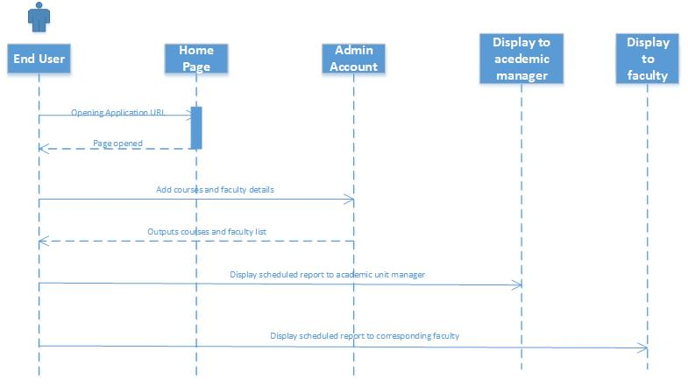

**System Architecture Diagram:**

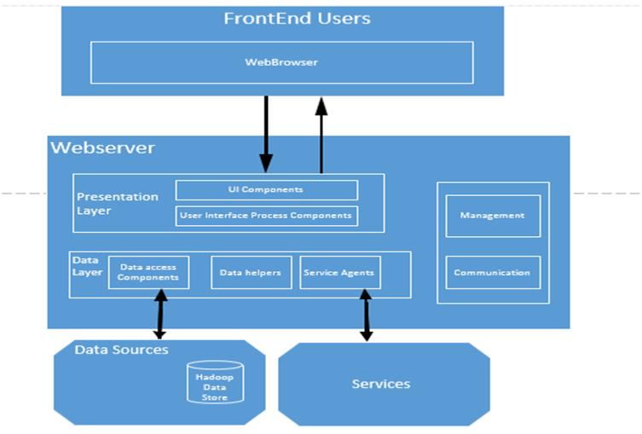

**Screen shot of our Interface:**

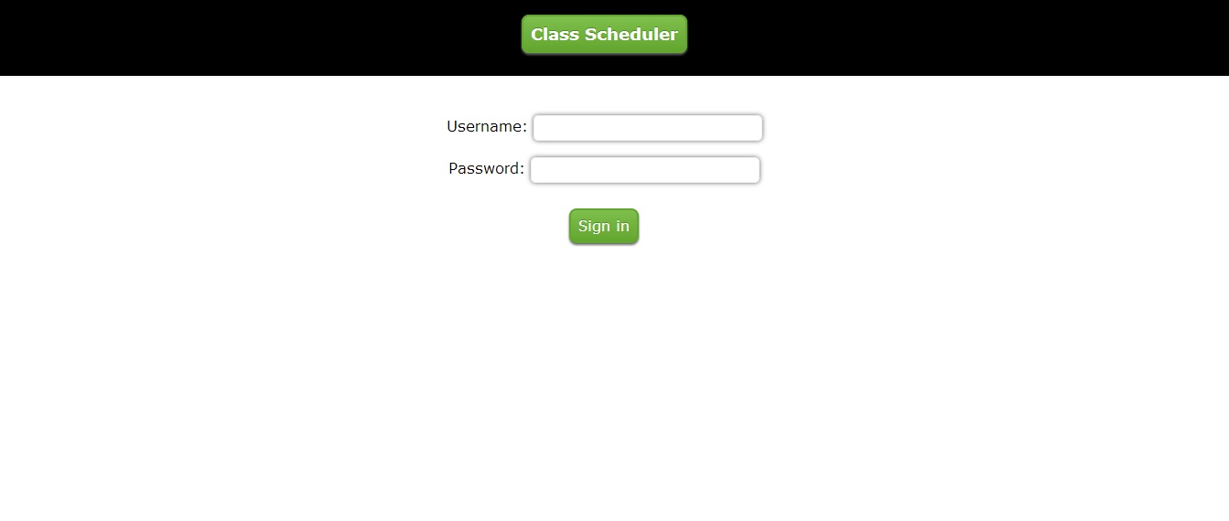

**C:\Users\Alekhya\Desktop\2 (1).jpg**

**Implementation**

**Implementation of services:** We created home screen for our project and also the chance to change the password for the users. The courses and the names of professors taking the courses will be entered manually and the classes will be scheduled systematically.

**Implementation of user interface:** Here we implemented the user interface using the HTML language and Cascading style sheets. The initial home screen is developed in this project for this increment. Further modules will be added in upcoming increments.

**Report:** In our project “CLASS SCHEDULER” we have developed the front end using HTML, JavaScript and CSS as part of First increment.

We added features which include “Change Password”, which allows the user to change the password whenever required.

We collected all the data regarding the courses offered in Graduate Computer Science Degree and the names of the professors for that particular courses from the UMKC website and also from the Academic department. The data also includes pre-requites for that courses if any.

**Step 1:** This is the home page of our project “Class Scheduler”. The user is asked to enter his username and password in order to login into.



C:\Users\Alekhya\Desktop\2 (1).jpg

Step 2: New users have to sign up by entering details like username, password, confirm password and email address.

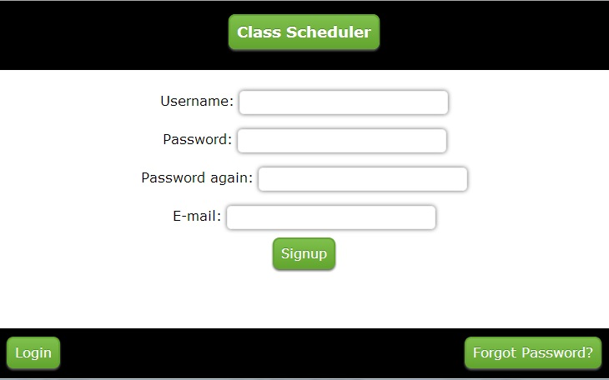

Step 3: After signing in the welcome screen will be as shown.

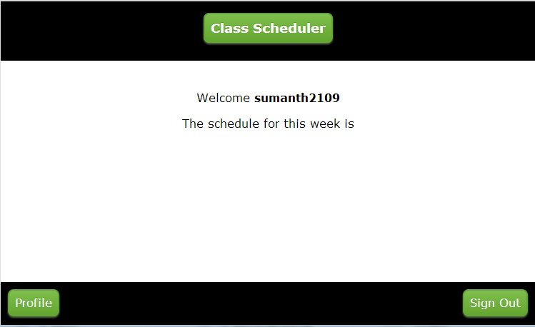

Here by clicking the profile option user can change his password by entering the old password then new one. It shows the password change confirmation window.

**Implementation Status Report**

**Work Completed:**

* **Description:** In the first increment, we completed the design of Web interface for the application using HTML, JavaScript, CSS and PHP. Also, we have collected data regarding the courses offered in the Fall 2013 semester. It includes the faculty concerned for a particular course, course name, and course number. In this web application, we have included features like:

1. Faculty Login accounts
2. Manager Login accounts

* **Responsibility:**

**Faculty Sign up Page:** The web interface for the Faculty to login in to their accounts

and to see their schedule is created by Alekhya.

**Admin/Manager Sign up Page:** The web interface for the manager to login into his/her

account and also add a particular semester and courses

into the semester along with details like course number,

course name and the faculty name has been created by

Sumanth.

**Collection of Static Data:** The course names, numbers and their respective faculty

details are collected by Savya and organized and analyzed

by Alekhya and Sumanth.

**Documentation:** Documentation for the 1st increment has been prepared by Alekhya

Boyapati and Sumanth Koushik Kalli.

* **Time Taken:** Individually, we have spent 70 hours each towards this increment.
* **Contributions:**

**Sumanth:** Creating web interface for Admin/manager, Analyzing data collected, creating dummy design layout, logic for scheduler and documentation.

**Alekhya:** Creating web interface for Faculty, Analyzing data collected and documentation.

**Savya:** Collecting data about Graduate courses in the Fall 2013 semester for analyzing, creating logic for scheduler.

**Work to be completed:**

* **Description:** In further increments, we are moving forward to complete the connection with database to get the course details, creative a dynamic schedule interface for display to faculty, add send email to faculty feature to the Manager’s account. We are also working on developing a good solution for communication of the faculty and manager, their acceptance to the schedule and also certain constraints on faculty member’s convinence.
* **Responsibility:**

Creating this web application in the future increments will be shared equally among all the team members. Alekhya is mainly involved in the database connection, logic creation. Sumanth is involved in writing code to schedule the courses and Savya is involved in creation a nice schedule form for faculty accounts.

* **Time Taken:** We estimate that we require around 100 hours each for an increment.

**Issues/Concerns:**

We haven’t had any major concerns in this increment. But, there were some minor concerns like finding out a better logic to schedule classes and classification of courses, faculty and the timings taking faculty and courses into concern.

**Deployment:**

**Scrum Do Link:** https://www.scrumdo.com/projects/project/class-scheduler/stories/#

**Github Link:** https://github.com/sumanth2109/AdvancedSoftwareEngineering/tree/master/Class%20Scheduler